**Commentary 1**

**Title of the article:** *Academics demand higher tobacco tax*

**Source of the article:** Taipei Times

<https://www.taipeitimes.com/News/taiwan/archives/2023/08/06/2003804322>

**Date the article was published:** 6 Aug 2023

**Date the commentary was written:**

**Word count of the commentary:**

**Unit of the syllabus to which the article relates:** Microeconomics

**Key concept being used:** Efficiency

**Academics demand higher tobacco tax**

Aug 06, 2023

By Chiu Chi-jou / Staff reporter

SURCHARGE GOAL: Last year the tax rate on a pack of cigarettes was 53 percent in Taiwan, which is lower than WHO recommendation of 75 percent, an expert said

Local academics and civic health groups have urged the government to follow the WHO guidelines and set a clear goal for increasing the tobacco health and welfare surcharge to effectively reduce tobacco use in Taiwan.

Based on the Tobacco Hazards Prevention Act, the government needs to re-evaluate surcharge adjustments every two years with specialists in the fields of finance, economics and public health.

The surcharge has not been adjusted in the past few years, although an evaluation meeting was held in November last year.

Lee Yue-chune, a professor of public health at National Yang Ming Chiao Tung University, yesterday said the tobacco surcharge adjustments in 2009 and 2017 led to a significant decrease in smoking, but it has not been increased since then.

The average price of a pack of cigarettes last year was NT$116 (US$3.66), with a tax rate of 53 percent, which is lower than the minimum tax rate of 75 percent recommended by the WHO, she said, adding that the decrease in tobacco use in Taiwan has slowed down.

Taiwan each year spends up to nearly NT$80 billion on healthcare resources to treat smoking-related illnesses, and smoking costs the economy more than NT$200 billion, Lee said.

The government needs to set clear goals for the tobacco health and welfare surcharge tax rate and increase it regularly to reduce Taiwan’s smoking population and save medical resources.

Taiwan has been slow

John Tung Foundation tobacco division director Lin Ching-li said most countries did not adjust their tobacco surcharge rates during the COVID-19 pandemic, but in the post-COVID-19 era, Hong Kong took the lead by raising the price of mainstream cigarette brands to about NT$304 per pack, with a tax rate of 62 percent.

The government has been acting too slowly to increase the surcharge, as the tax rate continues to remain at about 50 percent in Taiwan, she said.

Chung-Hua Institution for Economic Research deputy director Huang Shih-chang said raising the tobacco surcharge might trigger a backlash and encourage cigarette smuggling.

Therefore, the government needs to set up an automatic tobacco surcharge adjustment mechanism similar to the one in France, and gradually raise the tax rate based on national income, the inflation rate and price changes, he said.

In other developments, the Health and Promotion Administration (HPA) said that eight companies had applied to manufacture of import heated tobacco products (HTPs), as of Friday last week, but only one company submitted the complete documents required for review.

Based on amendments to the Tobacco Hazards Prevention Act, which were enacted on March 22, HTPs must pass a health risk assessment to be permitted for manufacturing, import, sales and use.

The companies need to apply for manufacturing or import approval in advance, and submit 13 documents required to conduct a health risk assessment.

As students might easily become HTP consumers, if the products are allowed to be legally sold in Taiwan, the government should strictly prohibit tobacco companies from misleading the public to believe that HTPs cause less health problems, Lin said.

**Commentary Planning Sheet Economics IB**

The overall aim is to use your economics knowledge to explain an event or change in the world around us.

Title of Article: Academics Demand Higher Tobacco Tax

Source: <https://www.taipeitimes.com/News/taiwan/archives/2023/08/06/2003804322>

Date: Aug 06, 2023

Key concept: Efficiency

Terms in the article or related to the article that would require definition:

1. Indirect Taxes

Taxes on expenditure to buy goods and services.

1. Negative externalities of consumption

Negative effect suffered by a third party whose interests are not considered when a good or service is consumed, so the third party is therefore not compensated.

What change/policy is discussed in the article?

The average price of a pack of cigarettes last year was NT$116 with a tax rate of 53%, lower than 75% recommended by WHO. However, the tax rate can only be increased gradually, with specialists’ evaluation and based on national income, inflation rate and price changes.

What diagram(s) could you draw and explain to illustrate this change? Sketch them. Often the first diagram will illustrate a problem, while the second diagram will show the suggested policy solution.

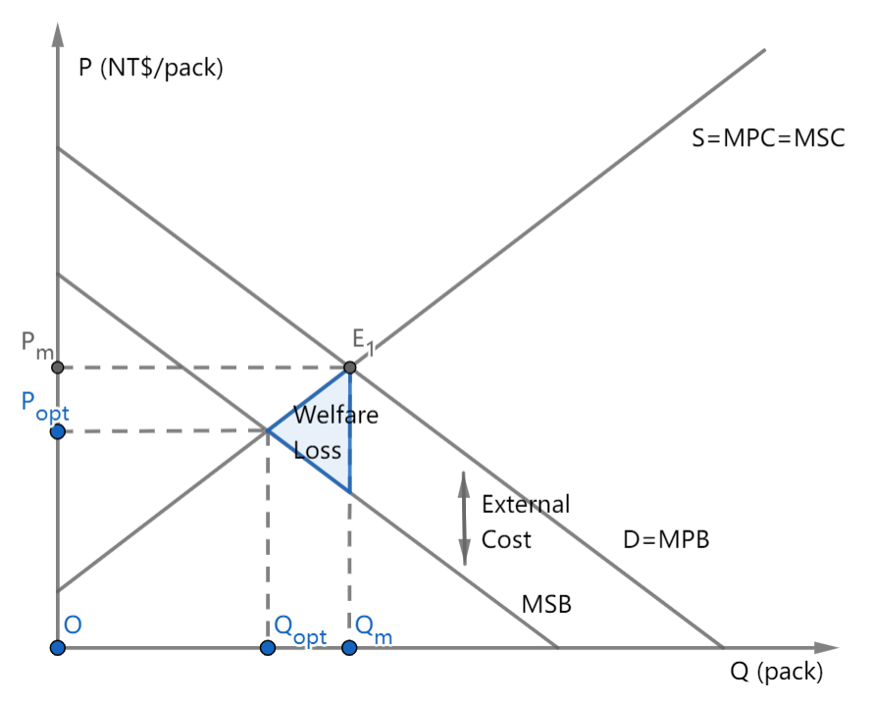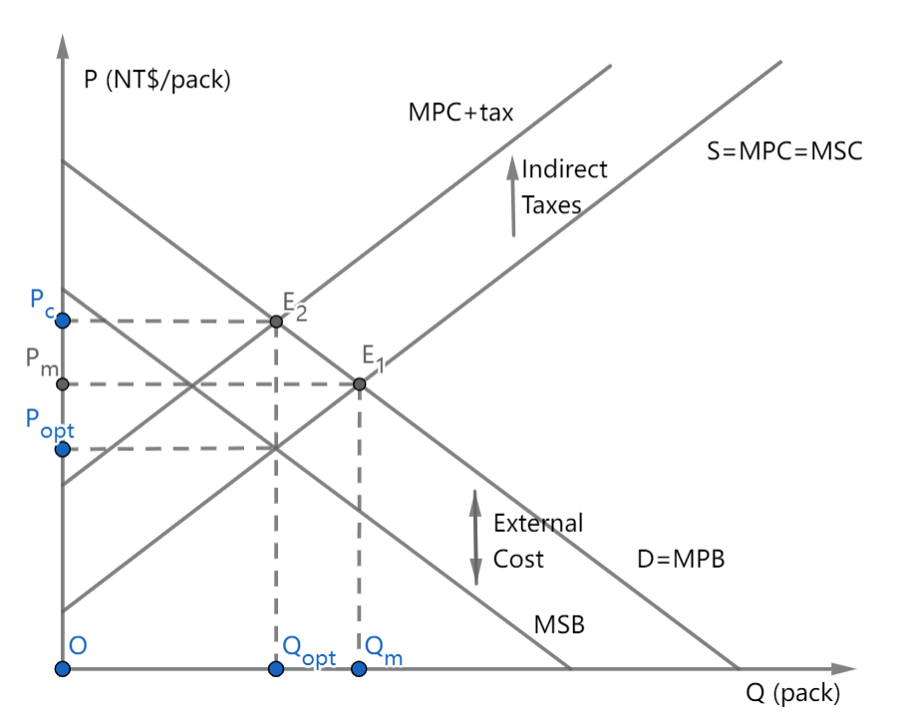

Now, evaluate this change. If there is a policy solution, is it likely to solve the problem? What are the likely effects, both positive and negative, or on various stakeholders? If you can, rank the impacts from biggest to least, with reasons. Lastly, for the best sort of evaluation, how does this instance reflect on economic theory itself? Does what happened or what is suggested in your news article accord with what economic theory suggests should happen? If not, why not?

Solution to NEC: imposition of indirect taxes

Connecting the statements with efficiency:

Advantages:

1. Internalize the externality (“The average price of a pack of cigarettes last year was NT$116 (US$3.66), with a tax rate of 53 percent”) and create incentives for consumers to change their consumption patterns and reach allocative efficiency ("the tobacco surcharge adjustments in 2009 and 2017 led to a significant decrease in smoking"). This approach aligns with the goal of internalizing external costs, promoting efficiency in resource allocation by encouraging healthier choices.

2. The imposition of tax can reduce Taiwan’s smoking population and thus save medical resources ("The government needs to set clear goals for the tobacco health and welfare surcharge tax rate and increase it regularly to reduce Taiwan’s smoking population and save medical resources", “Taiwan each year spends up to nearly NT$80 billion on healthcare resources to treat smoking-related illnesses, and smoking costs the economy more than NT$200 billion, Lee said”). By reducing the smoking population, this strategy aims to enhance allocative efficiency by optimizing the use of medical resources and improving overall public health outcomes.

3. Government can gain more revenue through tobacco taxation. This profit not only serves as a vital source of revenue for public services but also promotes economic efficiency. By levying taxes on tobacco, the government not only addresses market failures associated with smoking externalities but also signals the true societal costs of tobacco use. This encourages more economically rational choices and allows the government to strategically allocate funds, contributing to enhanced overall societal efficiency and long-term sustainability.

Disadvantages:

1. The tax-determining step is difficult: there exist difficulties in measuring how much tax should be imposed and it should be determined considering different factors (including national income, inflation rate and price changes…) ("the government needs to set up an automatic tobacco surcharge adjustment mechanism similar to the one in France, and gradually raise the tax rate based on national income, the inflation rate, and price changes"). Difficulties in measuring the value of external cost and how much tax to impose ("the government needs to re-evaluate surcharge adjustments every two years with specialists in the fields of finance, economics, and public health"). The challenge of accurately assessing external costs may impede the efficiency of the taxation system, necessitating periodic evaluations to ensure effective and efficient taxation.

2. Tobacco has an inelastic demand; Since the quantity demanded has a relatively smaller proportional change compared to the proportional change of price, to decrease the consumption of tobacco, the tax should be charged in a high price. (“with a tax rate of 53 percent, which is lower than the minimum tax rate of 75 percent recommended by the WHO”) To balance economic and political considerations, a gradual increase aligns with efficiency by avoiding sudden shocks to the market while still addressing public health concerns.

3. High tobacco surcharge may lead to growth in the underground market ("Chung-Hua Institution for Economic Research deputy director Huang Shih-chang, said raising the tobacco surcharge might trigger a backlash and encourage cigarette smuggling"). This potential growth in the underground market represents an efficiency challenge, as it may undermine the intended goals of the surcharge and lead to less effective regulation of tobacco consumption.